Surface Wave Amplification in the Bengal Basin: Theoretical and Numerical Insights into Basin-Induced Seismic Hazard

The Asian megacities of Kolkata and Dhaka sit atop the sediment-filled expanse of the Bengal Basin, one of the world's most densely populated but far from the Great Himalayas. For decades, seismic hazard assessments have focused heavily on major fault lines and rupture zones, but a critical, often underestimated factor is now demanding attention: the ground itself.
New research focused on the boundary between the ancient, rigid Shillong Plateau and the soft, deep sediments of the Bengal Basin has revealed a mechanism for earthquake wave amplification that is so severe it could multiply shake intensity by two to five times in urban areas. This work highlights a global imperative to move beyond simplified models and account for the complex interaction between earthquake waves and the heterogeneous, soft subsurface.

Understanding Seismic Wave Amplification in the Bengal Basin

The world of seismology is rich with complexities, especially in areas where geological features dramatically influence seismic wave behaviour. This is particularly true in the Bengal Basin, where thick sediments [1] overlay transitional crust, presenting unique challenges for understanding seismic risks in the region. For science enthusiasts eager to delve into the intricate dynamics of seismicity, our exploration of the Bengal Basin offers fascinating insights into the phenomena of wave amplification due to sedimentary geology.

The Geophysical Context

At the heart of our study lies the interaction between surface waves and geological structures. The Bengal Basin is known for its considerable sedimentary deposits, which contrast sharply with the more stable crystalline rocks of the Shillong Plateau. In between these contrasting geological structures, we have the Dauki Fault, which acts as a discontinuity between them. This transition creates conditions conducive to the amplification of seismic surface waves, a critical factor that can influence the intensity of seismic shaking during earthquakes [2].

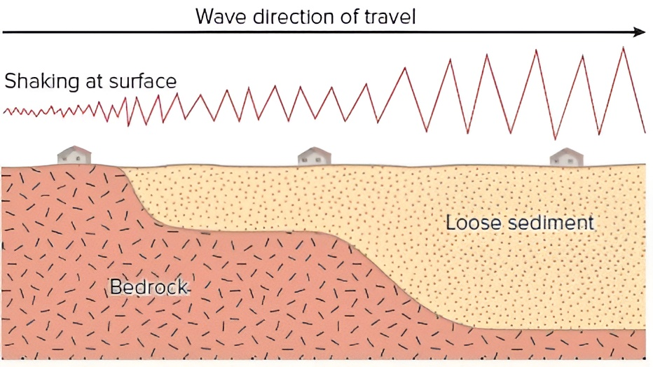

Fig. 1: Conceptual diagram showing how loose surface sediments amplify seismic waves.
As waves travel from stiff bedrock into softer sediment, their velocity decreases and their amplitude increases, causing stronger shaking at the ground surface.
When seismic surface waves travel from the dense, rigid terrain of the Shillong Plateau into the softer, sediment-filled valleys of the Bengal Basin, several factors come into play. Primarily, the lower shear-wave velocities intrinsic to the sediments and the impedance differences across the boundary of these terrains lead to significant surface wave amplification [2]. This phenomenon is crucial for understanding the potential seismic hazards faced by nearby urban centres, which often occupy these sedimentary basins.

A Tectonic Fault Line: Hard Rock Meets Soft Sediment
The danger zone lies along a stark geological transition. To the north, the Shillong Plateau is composed of crystalline bedrock, a dense, high-velocity crustal block [5] that serves as a relatively stable foundation. In stark contrast, the adjacent Bengal Basin is a colossal bowl of earth, filled with thick layers of Cenozoic and Quaternary sediments—silt, sand, and clay—deposited by the mighty Ganga and Brahmaputra River systems over millions of years.
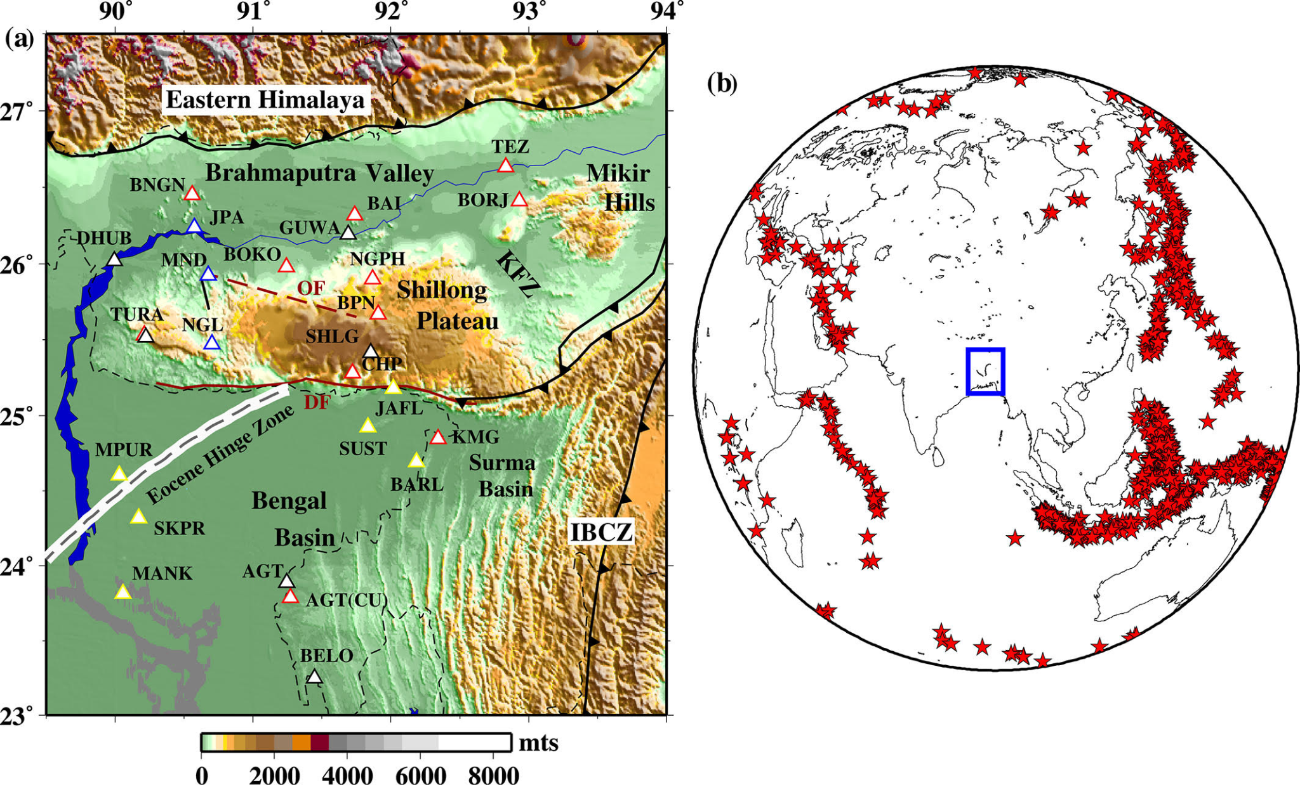
Fig 2: Topographic and seismotectonic map of the study area.
The map shows major physiographic features, active tectonic structures, and seismic stations across the Eastern Himalaya, Brahmaputra Valley, Shillong Plateau, Bengal Basin, and surrounding regions, highlighting the complex tectonic setting of the area.

The key scientific problem, and the source of the amplified shaking, is the impedance contrast at the boundary where these two terrains meet. Seismic waves travel through hard, crystalline rock (like the Shillong Plateau) quickly. When these waves encounter the much softer, lower-density sediments of the Bengal Basin, they behave like a fast car hitting a patch of deep mud: they slow down drastically.
This sharp change in velocity, specifically the lower shear-wave velocities (V_{s}) in the basin sediments, causes the seismic energy to be concentrated and amplified [3]. This effect is particularly pronounced for surface waves, which travel along the Earth's surface and carry a majority of the damaging energy, especially at lower frequencies.

Methodology: Shear Velocity Profiles and Modelling Techniques

To analyse the challenges posed by seismic amplification in this region, we employed a comprehensive approach using one-dimensional shear velocity profiles derived from various sites within the Bengal Basin and its adjacent crystalline terrains. Our study employed two main modelling approaches: semi-analytical simulations of surface wave propagation using SWRT (Surface Wave Reflection and Transmission) [4], and full waveform modelling with SPECFEM2D. The outcomes from both methods were then compared with real seismic observations to validate the results.
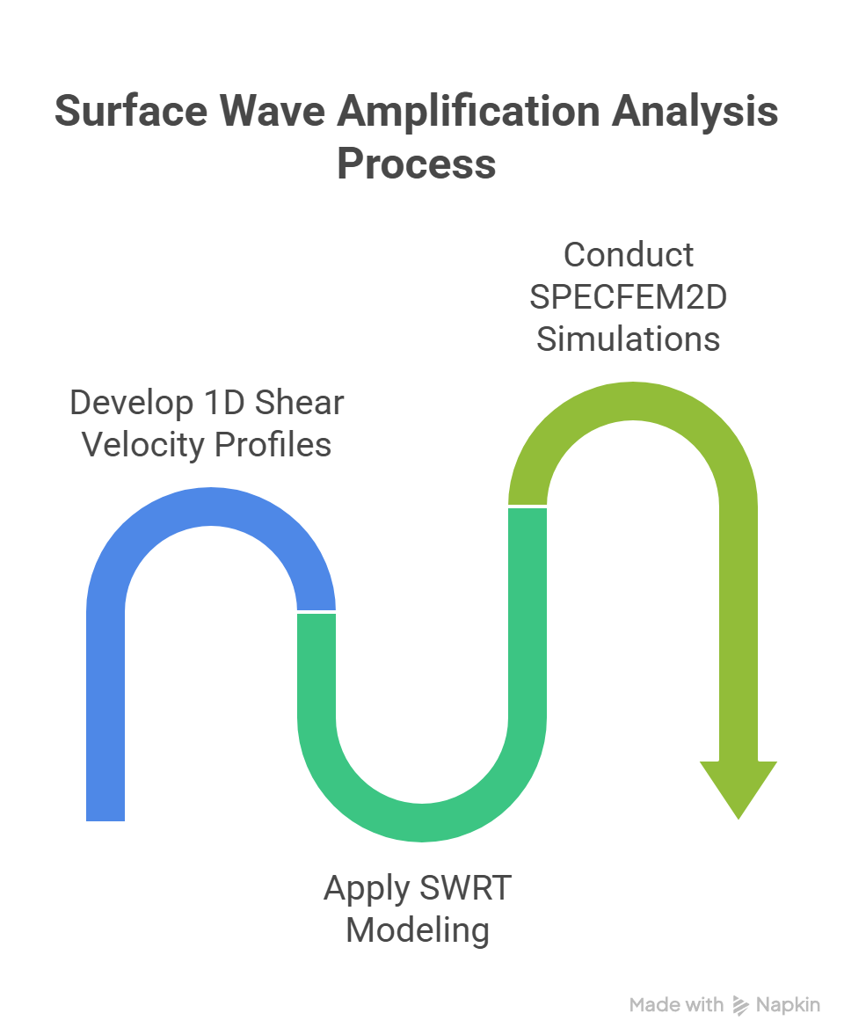
Fig 3: Workflow for estimating seismic amplification.
The diagram outlines the main steps of the analysis, beginning with developing 1D shear-velocity profiles, followed by applying SWRT modeling, and finally conducting SPECFEM2D simulations to evaluate surface-wave amplification.

The first computational method used was SWRT. This technique is semi-analytical, meaning it uses simplified mathematical equations to model how surface waves propagate across a sharp, vertical boundary—the kind that separates the Shillong Plateau from the Bengal Basin.
A crucial capability of SWRT is its ability to explicitly incorporate mode conversion. As a surface wave (like a fundamental Rayleigh or Love wave) hits the boundary, some of its energy is transformed into higher-mode surface waves. This mechanism of energy conversion helps trap seismic energy and redistribute it within the basin, contributing to the overall amplification.

The SWRT results were then validated using SPECFEM2D, a more computationally intensive full waveform simulation tool. SPECFEM2D solves the complete elastic wave equation, providing a highly accurate, dynamic picture of how the entire seismic wavefield interacts with the two-dimensional geological structure. By showing where the energy goes, SPECFEM2D essentially acts as a high-fidelity 'virtual seismograph' to confirm the predictions of the more simplified SWRT model.
By using these sophisticated models, we predicted that seismic amplitudes in the Bengal Basin could be 2-5 times greater than in the underlying crystalline terrain across the frequency range of 0.01 to 0.15 Hz. These predictions serve as a crucial reference when assessing the potential risks associated with earthquakes in this densely populated region.

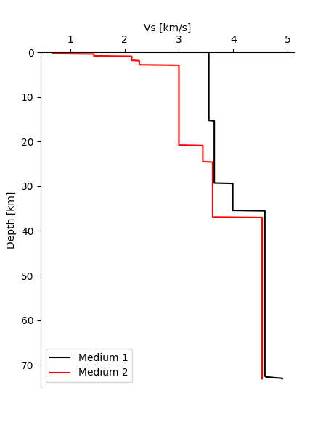
Figure 4: S-wave Velocity Profiles. This figure shows the S-wave (shear-wave) velocity variation with depth for two distinct regions: Medium 1, representing the Shillong area, and Medium 2, representing the Agartala area.

The Terrifying Forecast: Two to Five Times Higher Amplitudes
The predictions from both independent modelling techniques were starkly consistent:
Both SWRT and SPECFEM2D predict 2-5 times higher amplitudes in the Bengal Basin sediments than in the adjacent crystalline terrain.

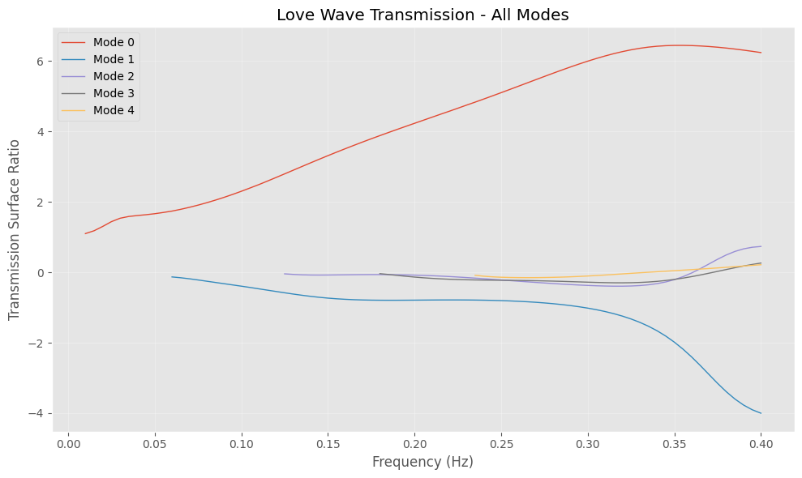
Fig 5: Predicted amplification of Love waves across different modes using SWRT.
The plot shows the transmission surface ratio as a function of frequency, illustrating how various Love-wave modes respond differently, with Mode 0 exhibiting the highest amplification at higher frequencies.

This significant amplification occurs across a crucial frequency band: 0.01-0.15 Hz. This low-frequency range is particularly dangerous because it corresponds to the natural resonant frequencies of tall structures like high-rise buildings and bridges. The amplified shaking at these frequencies can drive buildings into destructive resonance, magnifying structural damage far beyond what would be expected based solely on the earthquake's magnitude.

Confirmation from the Earth
Crucially, these computational predictions were not just theoretical. We compared their calculations to observations from a regional earthquake recorded at actual seismograph stations located on both the plateau and the basin. The analysis revealed that the observed amplification, particularly in the transverse component of the ground motion, showed good agreement with the model predictions. This observed match confirms that the combined effects of the low shear-wave velocity [5] and mode conversion at the lateral discontinuity are real and must be integrated into future hazard models.
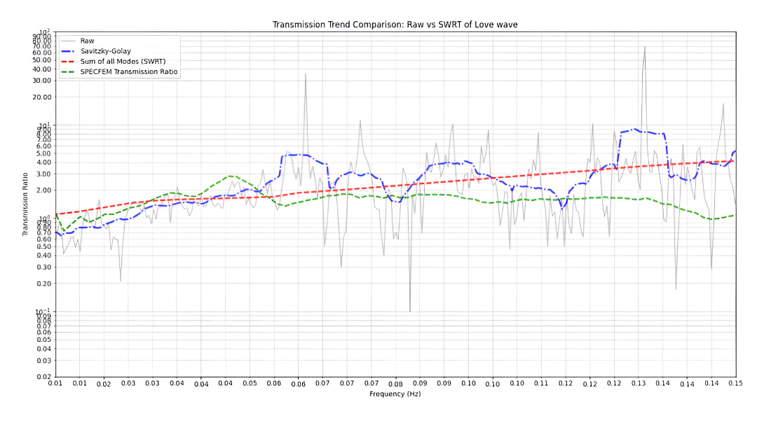
Fig 6: Comparison between predicted and observed Love-wave amplification.
The plot contrasts raw observational data with smoothed trends and SWRT- and SPECFEM-based predictions, highlighting how well the modeled amplification matches the measured transmission ratios across frequency.

Future Directions and Importance of the Study

Our study is just the beginning. We are committed to expanding our research by analysing a more extensive dataset, focusing on both the vertical and radial components of seismic waves. By further refining our understanding of wave propagation in this dynamic environment, we hope to develop more robust models for predicting seismic hazards in megacities situated on complex sedimentary basins.

The implications of our findings are immense; not only for the affected regions but also for the global community. As urban populations continue to grow and megacities emerge in geologically diverse areas, understanding the effects of lateral heterogeneities and sedimentary basins becomes paramount. Building resilience in these urban structures requires meticulous seismic hazard assessments informed by accurate geophysical models.

Conclusion

For science enthusiasts, the exploration of the Bengal Basin serves as a fascinating case study of how geological structures can mediate seismic risks in urban contexts. By unravelling the complexities of wave amplification, we contribute to a growing body of knowledge that aims to keep vulnerable populations safe from the unpredictable nature of earthquakes, ensuring a more secure future as we navigate the intricacies of our planet's geological tapestry. As our research progresses, we invite continued engagement and curiosity from both academic and public spheres as we strive to enhance our understanding of seismic dynamics in sedimentary basins around the globe.

References:
- Curray, J. R., Emmel, F. J., & Moore, D. G. (2003). A proposed super-thick sedimentary basin, Bay of Bengal. Marine Geology, 229(1–2), 5–15. https://doi.org/10.1016/S0025-3227(06)80002-1
- Bard, P.-Y., & Bouchon, M. (1980). The effect of sedimentary basins on surface waves that pass through them. Bulletin of the Seismological Society of America, 70(4), 1267–1286.
- Jayalakshmi, S., Dhanya, J., Raghukanth, S. T. G., & Mai, P. M. (2021). Hybrid broadband ground motion simulations in the Indo-Gangetic basin for great Himalayan earthquake scenarios. Bulletin of Earthquake Engineering, 19, 3319-3348. https://doi.org/10.1007/s10518-021-01094-0
- Datta, A. (2018). SWRT: A package for semi-analytical solutions of surface wave propagation, including mode conversion, across transversely aligned vertical discontinuities [Computer software]. Geoscientific Instrumentation, Methods and Data Systems, 7(1), 101-112. https://doi.org/10.5194/gi-7-101-2018
- Mitra, S., Priestley, K., Bhattacharyya, A. K., & Gaur, V. K. (2005). Crustal structure and earthquake focal depths beneath northeastern India and southern Tibet. Geophysical Journal International, 160(1), 227-248. https://doi.org/10.1111/j.1365-246X.2004.02470.x

